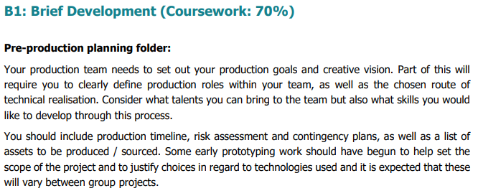

   Management of Production Work Log

EARTH: Deforestation

Production Roles

Project Manager: Jack King

Key Responsibilities: Managing tasks Organising meetings and ensuring work is completed to deadlines using tools such as trello

Audio Production: Jack Lynham

Key Responsibilities: Sourcing and implementing audio using FMOD

Animation: Hector Martin-Davis

Key Responsibilities: Animating the scene. Key animation such as trees, animals and vehicles.

Model Design: Luke Tolchard

Key Responsibilities: Sourcing and creating vital assets in Maya.

Lead Programmer: Lewis Bond

Key Responsibilities: Scripting and event triggers using c# scripts within Unity.

**Week 1 - 14/11/2019**

This week tasks were delegated to each team member to be completed by Thursday. To make sure the Quest can handle the rainforest testing a scene with lots of models was planned to test the technical capabilities of the Quest. The initial storyboard was also created to have a solid foundation of our concept to allow the team to iterate and develop. Fundamental asset and audio lists were created and to be sourced by Thursday.

**Jack King -** This week, I created a basic plan for our storyboard so we can make ideas more concrete and change it if needed moving forward.

**Lewis Bond -** Research was done into how to setup quest VR for preparation for next week

**Hector Martin Davis -** Basic models were found such as trees so we can import them when getting around to getting a scene working with our virtual reality headset.

<https://www.youtube.com/watch?v=Ys6CV4sseNc>

**Luke Tolchard** - Some assets were researched for future reference so we can quickly download and test them within our VR scene

**Jack Lynham** - Basic audio list outlined primary audio we will need for the development of our game.

**Week 2 - 21/11/2019**

**Jack King** - This week I refined the idea as a whole with the team and found some potential assets that the group can use. A basic low poly forest pack was found we can use for testing the capabilities of our Virtual Reality headset.

**Lewis Bond** -  Collected the oculus quest from Tom Garne. Attempted to get the quest running but had difficulties with the oculus integration package from the asset store.

**Hector Martin Davis** - Tested animation on trees and animals in maya, unsure of the impacts on the VR quest. The quality of the models and animations were too high resolution for our project, as we are going to aim for a low poly project. The aim of this was to test animation quality and get an idea for what has to be done for our project.

**Luke Tolchard** –

**Jack Lynham** -  This week I gathered some Fundamental research for the project ahead this gave me a basic understanding of the scope of the issues involved and what to research next.

**Week 3 - 28/11/2019**

**Jack King** + **Lewis Bond -** Managed to the quest working and displaying a cube. Removed the oculus integration package and this is what fixed it. There is no interaction in the scene, until the problem with the oculus integration is fixed as this handles the interaction for the quest.

**Luke Tolchard** –

**Jack Lynham** - This week I looked into the main products that were causing deforestation and all the different ways deforestation could be prevented. This is because we want to tell our users at the end of the experacne how they can help make a difference

**Jack King** -  This week I managed to create a basic demo scene with low poly terrain and scenery with a slowly rotating camera so we can test the capabilities of our headset and get a good understanding of how our scenes will look moving forward. Sounds randomly play every 10 - 15 seconds to make it seem more natural and like a jungle. Cicadas are constant sound within the jungle so the sound loops throughout the demo scene.

**Lewis Bond** - Implemented a raycast that destroys any trees the player looks at. This is done by changing the opacity on the model. It uses a raycast to detect all the objects in a direction and the first one to have the tag of “Tree”.

**Hector Martin Davis** – Created Google power point for team members to start filling in their slides, I also started working on my slide.

**Luke Tolchard** –

**Jack Lynham** - This week I Focused on Narration as this is large part of the project and i have begun drafting a script.

**Week 5 - 12/12/2019**

**Jack King** - This week I tweaked the introduction demo scene and solidified the group idea so we know what we need to do for next semester.

**Lewis Bond** - Finished my part of the pre-production document.

**Hector Martin Davis** – This week I made progress towards learning features of blender for future learning when creating animations.

**Luke Tolchard** - The addition of low poly trees to the terrain has produced much better results in performance than last weeks test. If we use walls behind several layers of trees to give the illusion of a forest environment that extends longer than it actually does from the players perspective, we can also save on the amount of models on screen without sacrificing a sense of enclosure and immersion.

**Jack Lynham** - This week I worked on My areas in the pre production document. Mainly scene planing and the Script outline.

**Week 6 - 23/01/2020**

**Jack King -** This week I worked on the terrain generation. Initially I created a unity terrain for the general layout which I then turned into a mesh using a script. Once it was an OBJ file format or mesh it was easy to edit in Blender and making low poly. After it was low poly i needed to colour it. To colour it i used the offset of the vertex Y data of the mesh, normalised all of the vertices which turned it into a value between 0 - 1 and then set colour regions based on the height of the vertex. We also decided that we are going to have a UI which acts as visual feedback for the player as they destroy trees/surroundings using their gaze.

**Lewis Bond** - This week I worked on generating another terrain to be used in other scenes. I used the same method as Jack to convert the terrain into a mesh and then used Blender to make it low-poly. This terrain was slightly different as it has a large flat area where the farming plantations will be placed to show the devastation to the rainforest.

**Jack Lynham -** This week I was tasked with Writing the Script, so far I have written the first two scenes, however my other task finding someone to narrate for our project has proven troublesome, which will require more searching in the following weeks. For the next few weeks i will need to carry out more research, as i believe more is required to create a  good script.

**Hector Martin-Davies –** This week I Imported assets being animals and machinery, the animals imported were a cow, monkey, crocodile and then for machinery I also imported a bulldozer. But the bulldozer possible going to be scraped as there were problems importing it into unity.

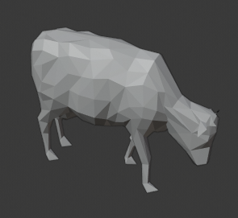

**Week 7 - 30/01/2020**

**Jack King -** This week I have improved the audio manager so sounds can fade in/out. I also added models for the title and the world for the introduction scene. General development on the introduction scene has begun. I found a low poly Earth model and created models for the title screen. An Effects Manager class was added to increase work efficiency and duplicating code. A cloud generator was also added to allow clouds to spawn and move across the scene with variety.

**Lewis Bond** - Added the root prefabs for 2 of the scenes I am implementing. The 3rd scene where the forest gets set ablaze and also the 4th scene where it shows how farming is taking up space for the rainforest. Also add in camera with raycast which will destroy the trees again when they have been implemented.

**Jack Lynham -** This I was unavailable due personal circumstances however, in following weeks I will conduct more research and write the script. Fix english

**Hector Martin-Davies –** From the previous week, I have rigged the cow and crocodile model and also animated the cow. The other models that were imported had problems being imported into blender. I am unsure if I am able to fix this.

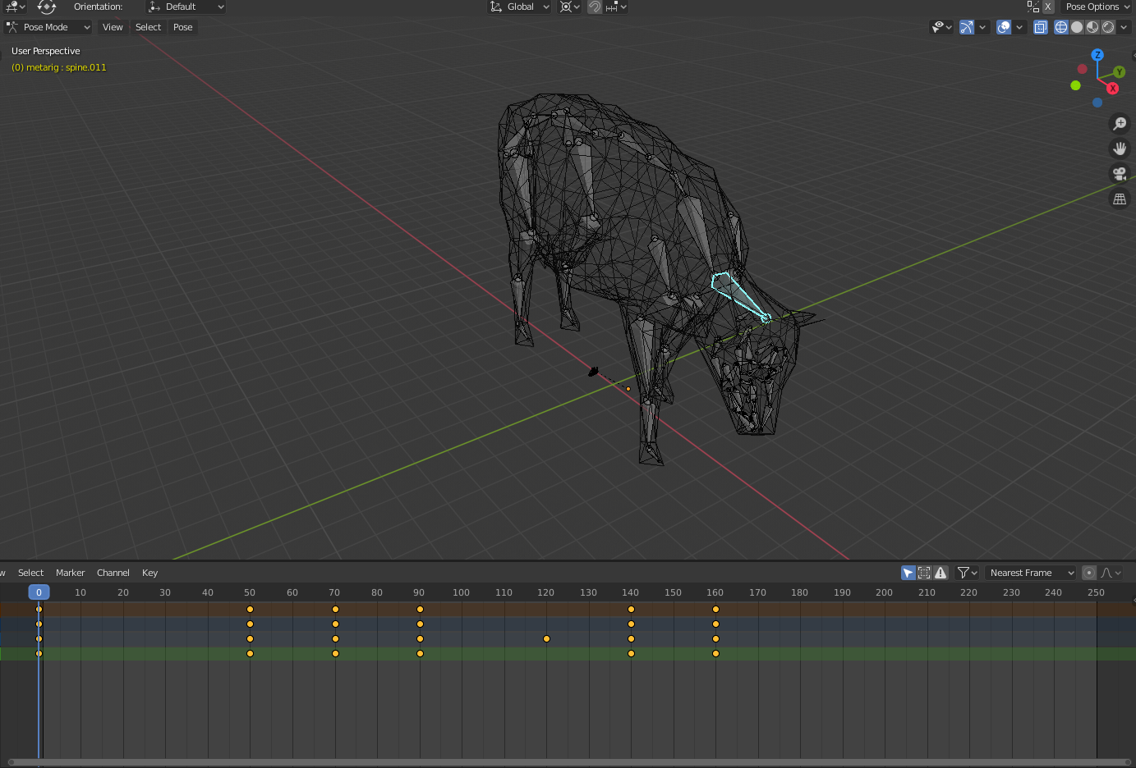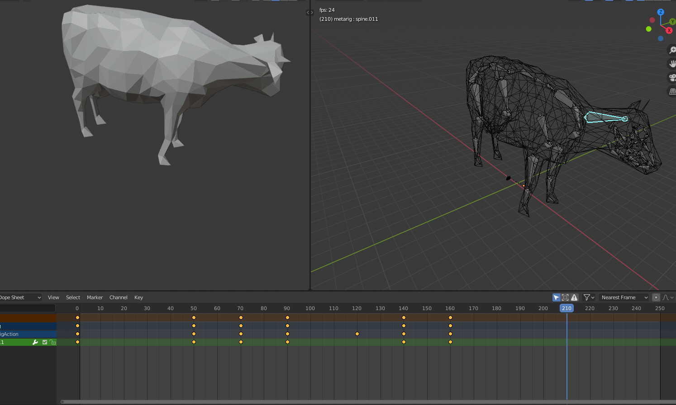

**Week 8 - 06/02/2020**

**Hector Martin-Davies –** Finished and perfected Cow animation for being ideal while eating grass and being in a field.

**Week 9 - 13/02/2020**

**Hector Martin-Davies –** Working towards rigged a Monkey model, results have shown that it has not been successful. Requiring a new model, image below shows a reoccurring problem with the rigging and model. Image on the left showing the rigging being created and the right image showing result of rigging. The skeleton being outside of the body with the legs not working correctly.

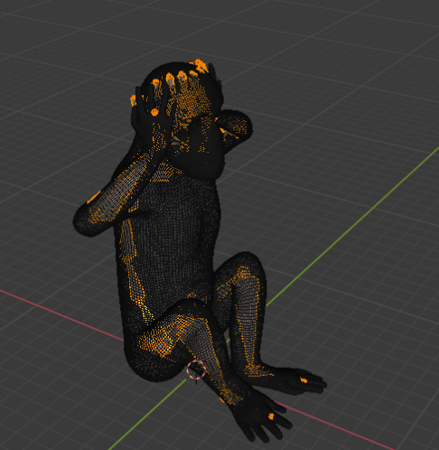 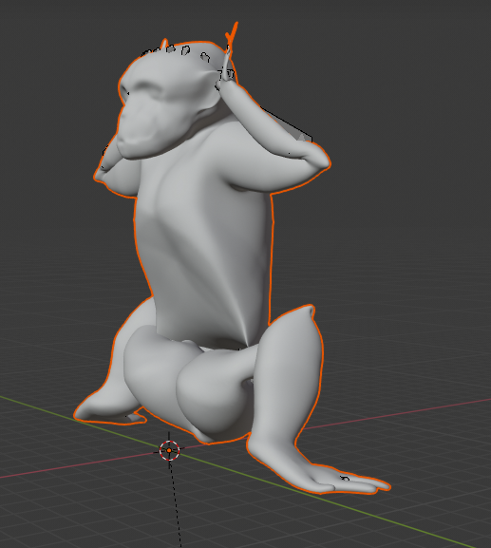

**Week 10 - 20/02/2020**

**Hector Martin-Davies –** After last week I have found a few new monkey models. Some models have had similar problems to the previous. Others not being suitable, looking for a new one.

**Week 11 - 27/02/2020**

**Hector Martin-Davies –** During this week I have found a new Monkey model that is working with my rig test, I plan to use this model once it is fully rigged. The image below is of the model I plan to finish rigging and animate.

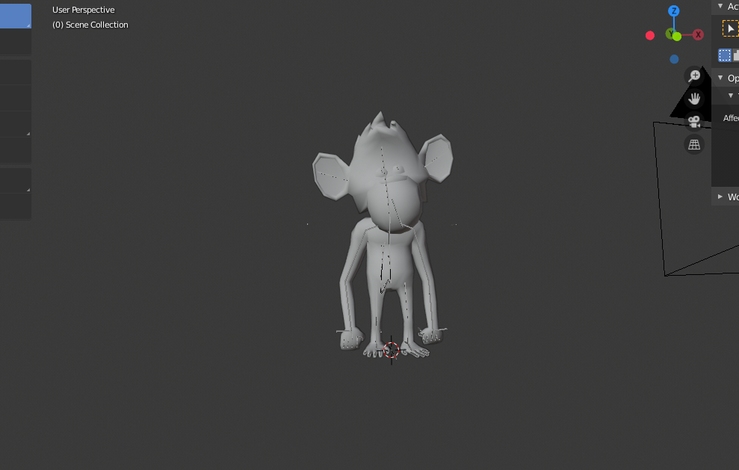

Pre-Production Document

**Overview**

“Earth Deforestation” is an experience built in the Unity game engine. The idea is to educate people about the effects of deforestation by taking them through different scenes. The rainforest will change throughout the experience demonstrating how fires, farming and oils(soya) cause devastation on the Amazon.

**Scene 1 – 30 seconds**

Introduction from Global-View slow zoom into the amazon rainforest.

**Scene 2 – 2 min**The user is in the rainforest; it appears to be beautiful and full of life and nature. The narration will talk about some critical aspects of the rainforest, i.e. how much land it covers globally. As well as how much biodiversity exists. It will then mention the fires in amazon in 2019 and shows the reality and switch to the next scene.

**Scene 3 -1:30 m**

In the scene, the rainforest is burning this scene will be more of a visual scene with little narration. It will merely show the devastation a fire can cause. In the scene the narrator will say why does this happen and transition to scene 4

**Scene 4 – 1:30 min**

In this scene we will show farming products(Beef, Palm Oil, Soy) as they are the main reason why these trees are cut down. This will go into more of the business of cutting down trees.It will then say; however, this has a massive effect on life within the Amazon Rainforest then switch scene.

**Scene 5 1:30 min**

This New scene Lots of dead trees, talking about the permanent effects of Global warming.more of a visual scene shows some indigenous peoples and animals for affect then Switch to the final scene.

**Scene 6 2 min**

A final scene like the first scene shows rainforest, but all the trees are dead or gone. goes over the rainforest in an aerial cam. Mainly narration and talks about how it can be stopped and then once description finishes, the trees grow back then fades to black.

**Core Interaction/Mechanics -** The player will inadvertently be felling trees in the direction of their gaze. The purpose of this interaction is to make the player feel a sense of responsibility for the destruction happening around them, even if they don’t feel any benefit to it happening. This will help to empathise the player with the real struggle of deforestation and help them to realise their effect on the demand for it, and start to make them think about how they can reduce their impact.

**Design -** For the design we have decided on a low poly design, we chose low poly as it will perform better on the VR quest. However,  we are unsure of the capabilities and full potential of VR quest.

**Storyboard -**

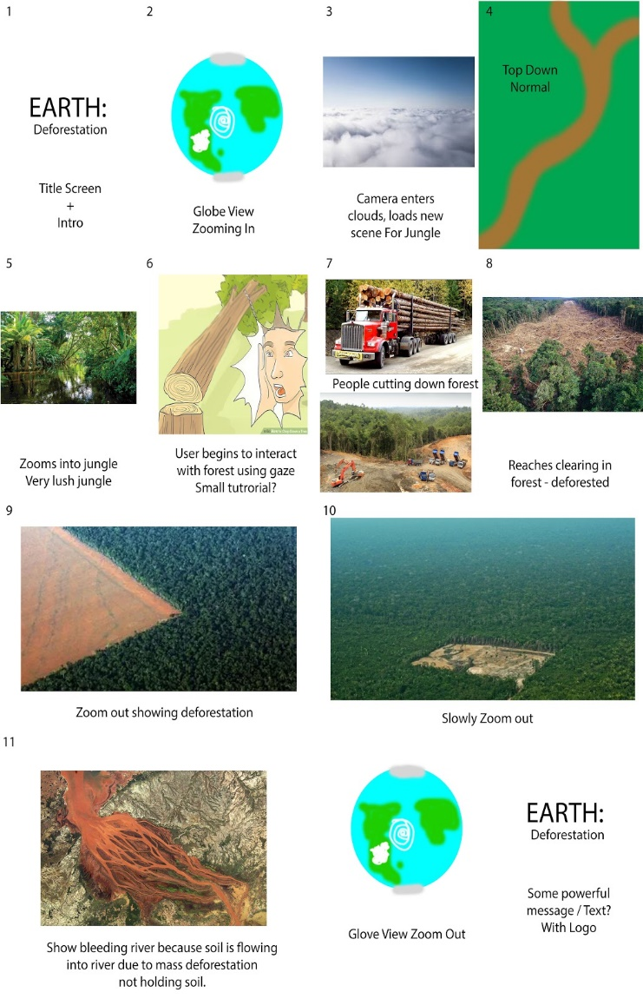

**Audio -**

The audio will change as the experience progresses.

Music/Sound Effects List:

* Howler Monkeys
* Cicadas
* Amazonian Bird Sounds
* Fire sounds
* River sounds
* Saw sounds
* Falling Trees
* Burning trees
* Narration

As the experience progresses, sounds will slowly decrease and be replaced by more unnatural sounds such as chainsaws and fire. Cicadas sounds will stop along with monkey and bird sounds.

**Consumer Outcomes -** The desired outcome of our experience is to raise awareness for the disaster of uncontrolled deforestation, and the impacts it has on a whole range of life. We want to engage the user in a thought provoking ordeal and immerse them in the struggles of the indigenous species and citizens, with an overarching goal of moving people to the extent that they change their own consumer habits to make a positive change.

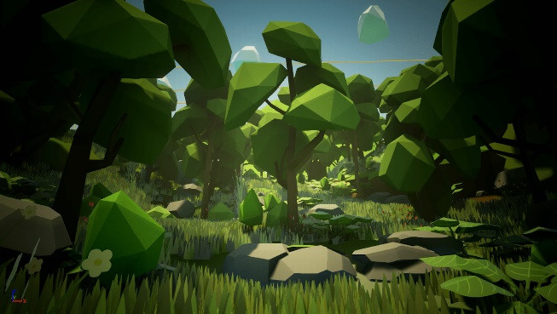

**Technical Realization -** Get the project to run on the oculus quest with a consistent frame rate that is usable. Might require to scale down the project, for example, the models for the environment have already been altered to low poly models for it to run smoothly on the quest. The number of animals and other objects will have to be reduced as well. So the quest can is overloaded by the scene.

**Mood Board -**

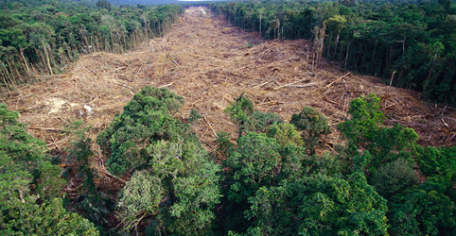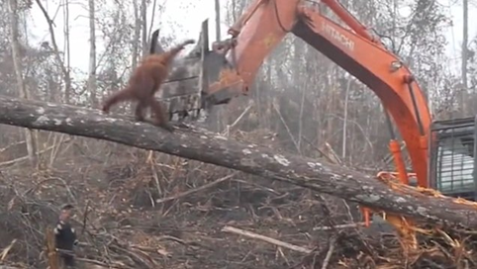

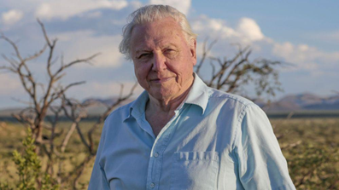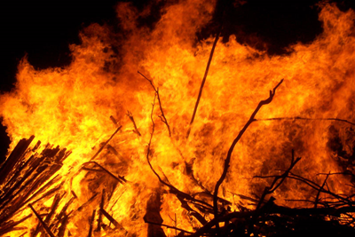

**Shot List** (Shots we want to include for our final vision/experience)

Introduction

* Zooming into a model of Earth. Then transitioning
* The player looking around deforesting the area around them
* Fire burning around towards the player with no escape
* Trucks going by full of logs
* Pan zoom out showing mass deforestation.

**Scene References / Shot inspiration examples -**

**Ideas for vision mechanic:**

* Trees being cut down
* Animals dying
* Fires spawning
* Vehicles starting up

**Model ideas**

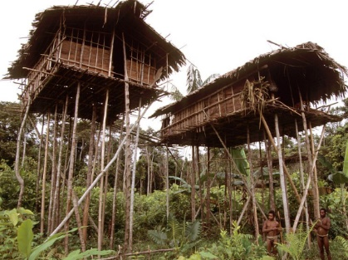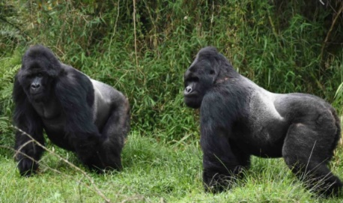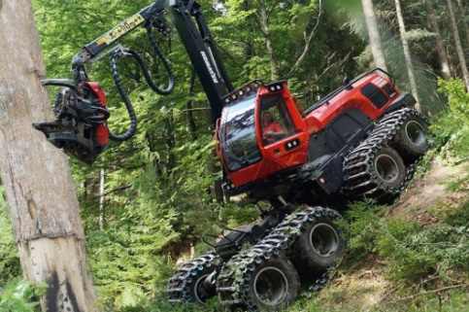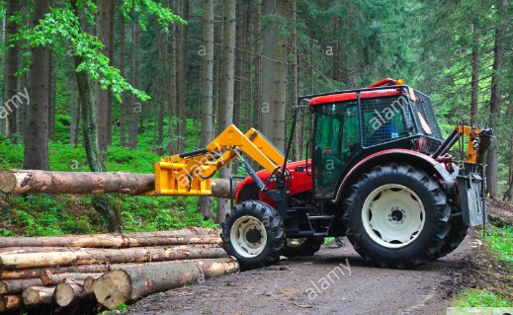

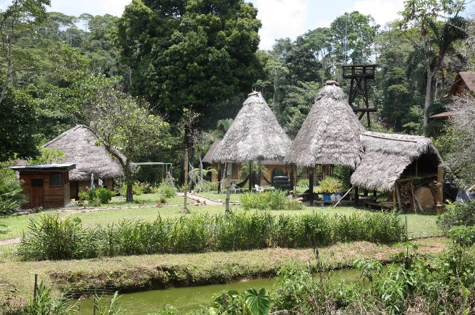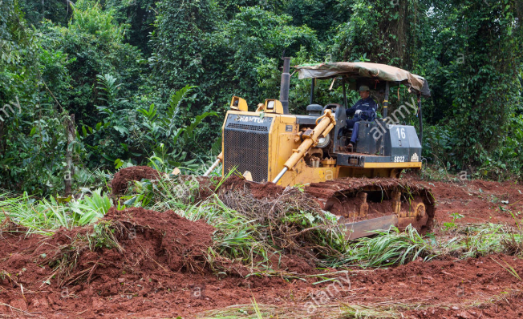

|  |  |  |
| --- | --- | --- |
| Risk | Mitigation | Contingency |
| Quest can’t handle rendering a complete rainforest. | Use low poly models to reduce memory demands and occlusion to reduce how much is rendered per frame. | Reduce the number of trees/meshes in the rainforest with less detailed mesh. |
| Motion sickness from intro and outro. | Keep transitions short and sparse, so they don’t have time to affect the user | Get rid of it and implement a fade, so there is no motion. |
| Audio sourcing is confusing due to so much happening around the player. | Make sure objects are properly destroyed when they are no longer relevant to keep invisible objects from interfering with the scene | Reduce the amount of audio emitting objects in the scene. |